Bosch Rexroth AG
Postfach 1162
64701 Erbach
Berliner Straße 25
64711 Erbach
Tel. +49 6062 78-0
Fax +49 6062 78-428
www.boschrexroth.com

How-To
New Welding System – REST API

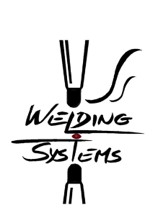

Firmensitz: Stuttgart, Registrierung: Amtsgericht Stuttgart HRB 23192
Vorstand: Rolf Najork (Vorsitzender), Dr. Markus Forschner; Dr. Steffen Haack; Dr. Bertram Hoffmann
Vorsitzender des Aufsichtsrats: Dr. Werner Struth

Htttp request body example for reading weld controller parameters:
{  "read-or-write" : "read",  "request" : "spot",  "overview-list" : "no",  "id" : "",  "name" : "Spot_12_231"  } | //Required (“read”,”write”)  //Required (”spot”,”weldjob”,”tip”,”gun”)  //Required (”yes”,”no”)  //Required (integer or “”)  //Required (string)

Htttp request body example for modifying weld controller parameters:
{  "read-or-write" : "write",  "object":{"xHeader": {  "s32InvokeID": 5,  "s32ResponseCode": 0,  …  }  …  }  } | //Required (“read”,”write”)  //Required (JSON from reading request)

Example using Postman Chrome App to access the NWS REST API:
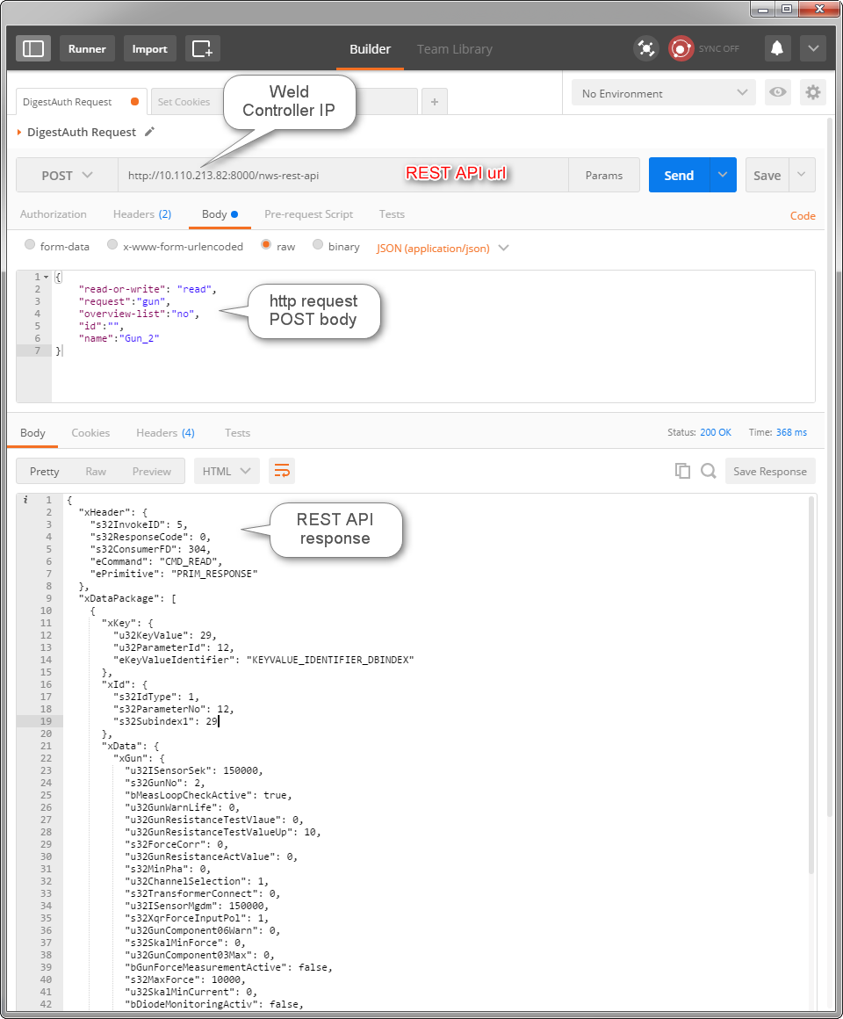

POST Request:
Using the POST request the client can read and write weld control parameters.
Url: http://<controller-ip>:8000/nws-rest-api
POST Request body objects info:
"read-or-write"
Definition: | Indicates if API is only returning JSON from weld controller (“read”) or if API should write a new object in weld controller.
Required: | Yes
Values: | “read” and “write”
Examples: | …  "read-or-write": "read",  …

"request"
Definition: | Indicates which object is being requested to be read or modified.
Required: | Yes (only for “write-or-read”: “read”)
Values: | “tip”,”spot”, “gun”, “weldjob”
Examples: | …  "request": "spot",  …

"overview-list”
Definition: | Indicates if API should return the complete list of requested object (eg. List of different spot in the weld controller) or if the API should return only one object using id or name as a filter.
Required: | Yes (only for “write-or-read”: “read”)
Values: | “yes” and “no”
Examples: | …  "request": "spot",  "overview-list" : "yes",  …

"id”
Definition: | Indicates which object (eg. spot with id = 101) should be selected. Id is an internal number in the weld controller. The list of ids and names can be seen using “overview-list”:”yes”.
Required: | Yes (only for “write-or-read”: “read”)
Values: | Integer or “” (empty string)
Examples: | …  "request": "spot",  "overview-list":”no”  “id”:10  …

"name"
Definition: | Indicates which object (eg. spot with name = “Spot_10213”) should be selected. The list of ids and names can be seen using “overview-list”:”yes”. The object name will be only used if id is set to “” (empty string).
Required: | Yes (only for “write-or-read”: “read”)
Values: | Any string
Examples: | …  "request": "spot",  "overview-list":”no”,  “id”:””,  “name”: “Spot_10213”  …

"object"
Definition: | Corresponds to the modified object JSON (previously obtained when using “read”) that should be sent to the weld controller in order to modify the weld parameters.
Required: | Yes (only for “write-or-read”: “write”)
Values: | JSON Object
Examples: | {  "read-or-write" : "write",  "object":{"xHeader": {  "s32InvokeID": 5,  "s32ResponseCode": 0,  …  }  …  }  }

GET Request:
Using the GET request the client will receive information about the latest weld such as voltage curve, current curve, spatter time, weld quality index (UIP) etc.
Url: http://<controller-ip>:8000/nws-rest-api/last-weld

Example:
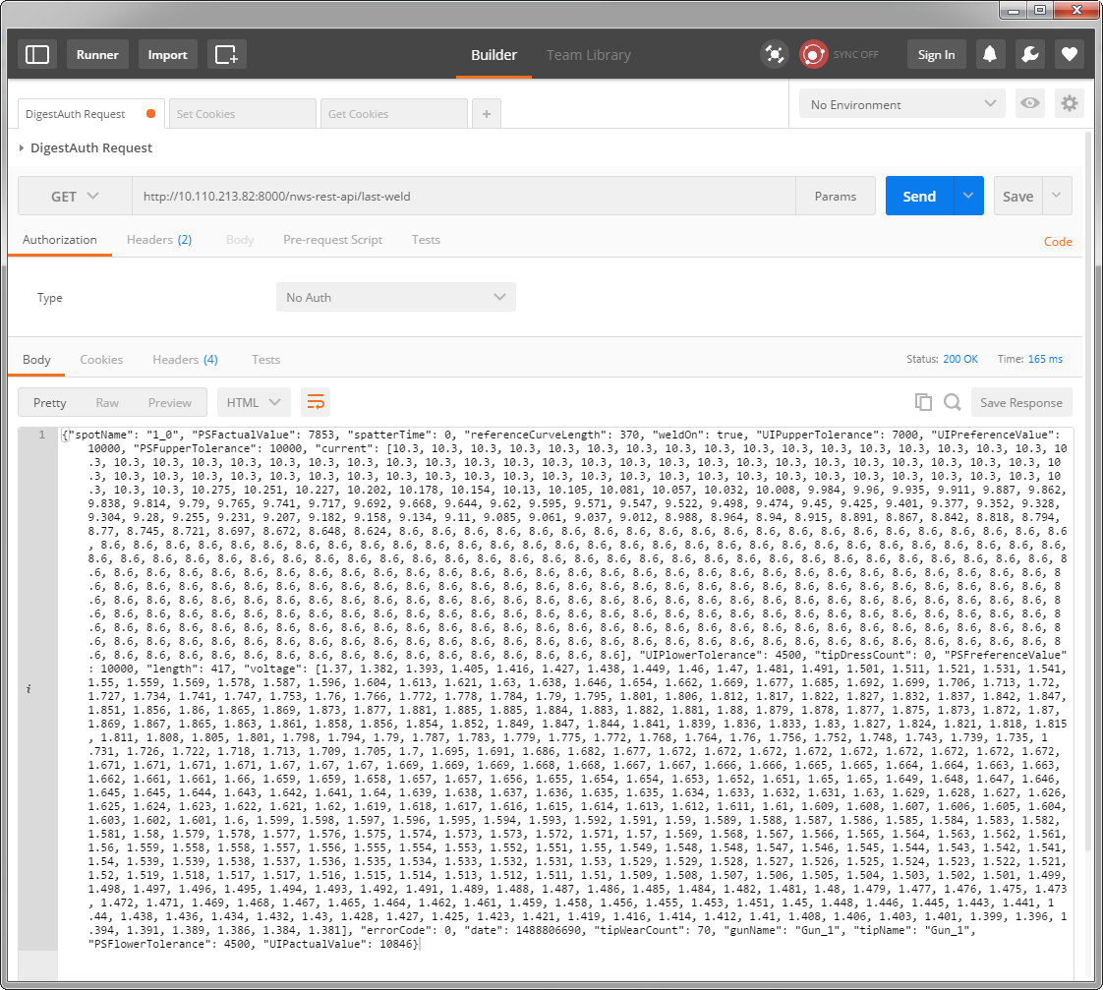

Contact Info:
Florian Genge - florian.genge@boschrexroth.de
Sebastian Zeller - Sebastian.Zeller@boschrexroth.de
Sven Hansen - Sven.HansenGoncalves@boschrexroth.de

